# Exercise 2 - The Platform

In JMP we launch a Platform, which is what is used for doing some kind of analysis.

1. Start JMP
2. Examine various windows opened automatically, then close them
3. Open a table using Help/Sample Data/Teaching Resources/Examples for Teaching/Auto Raw Data  
   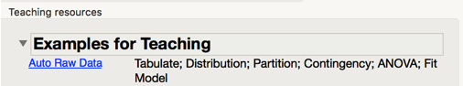
4. Analyse/Distribution

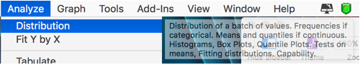

1. Select all columns (control A)
2. Click on 
   1. OK
   2. Examine outputs
3. Click on a bar, see all that data in other histograms highlighted
   * 1. Click on bar, then right click and choose subset

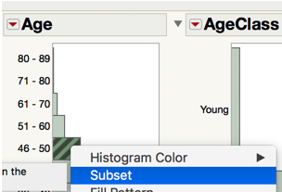

* + 1. This makes a table with just those rows in it

1. Columns are those marked with a label icon in the table 
2. Go back to table and look at what is marked with labels by using 
3. You can mark more columns as labels, and these can then be subsetted - try that
4. Click on some red triangles to explore options available
   * 1. Click on red triangle next to distributions at top left, choose to save to a Flash file

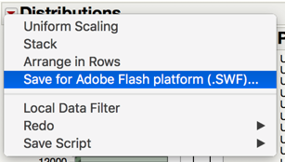

* + 1. Web page opens with an interactive web view of this platform

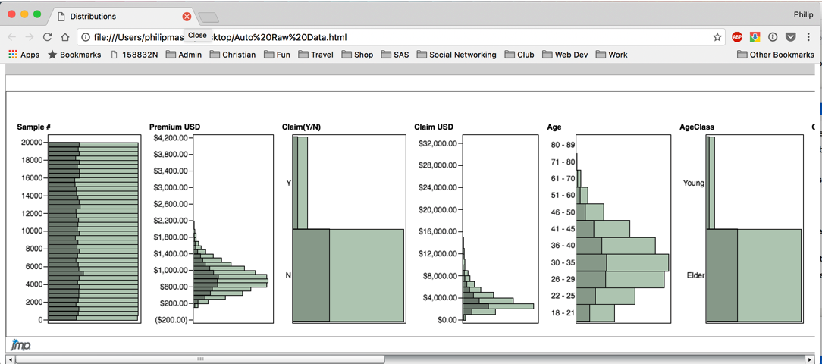

1. Add a local data filter using 
2. Select Age and press Add
3. Select different ages to see distributions change
4. Open another distribution using Analyze/Distribution
   1. Just choose one Y, Column - then OK

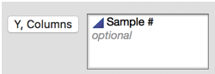

* 1. Choose the Column Switcher tool

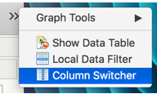

* 1. Choose numeric columns, OK

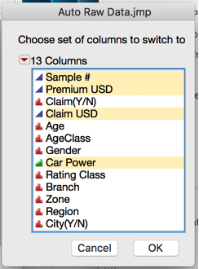

* 1. Now you have a column switcher

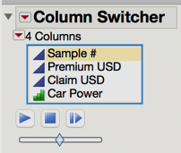

1. Select different values to see effect
   1. Click on play to see what happens

